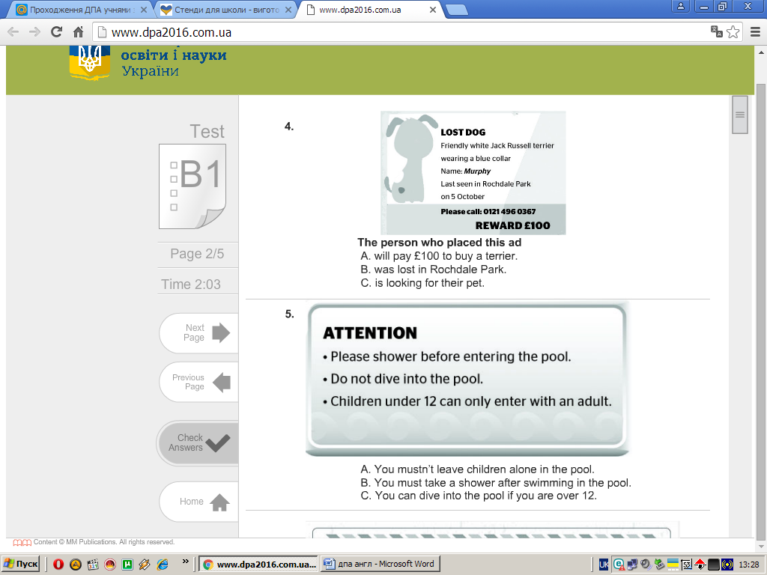**Task 1. Read the announcements and choose the best variant:**

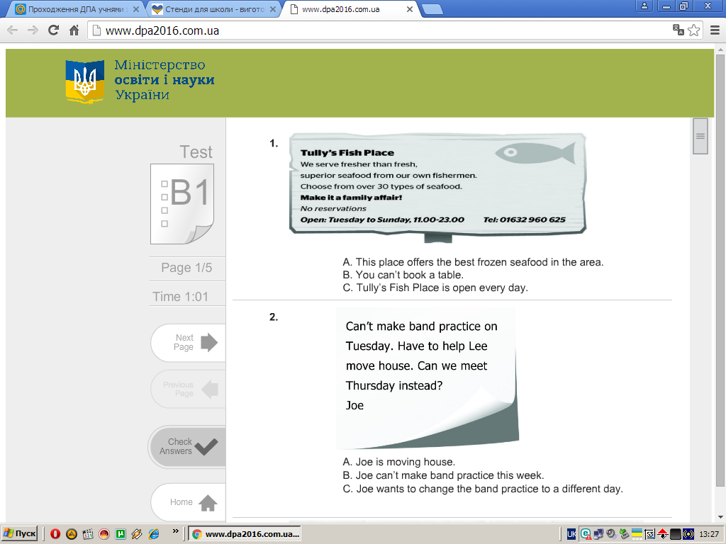

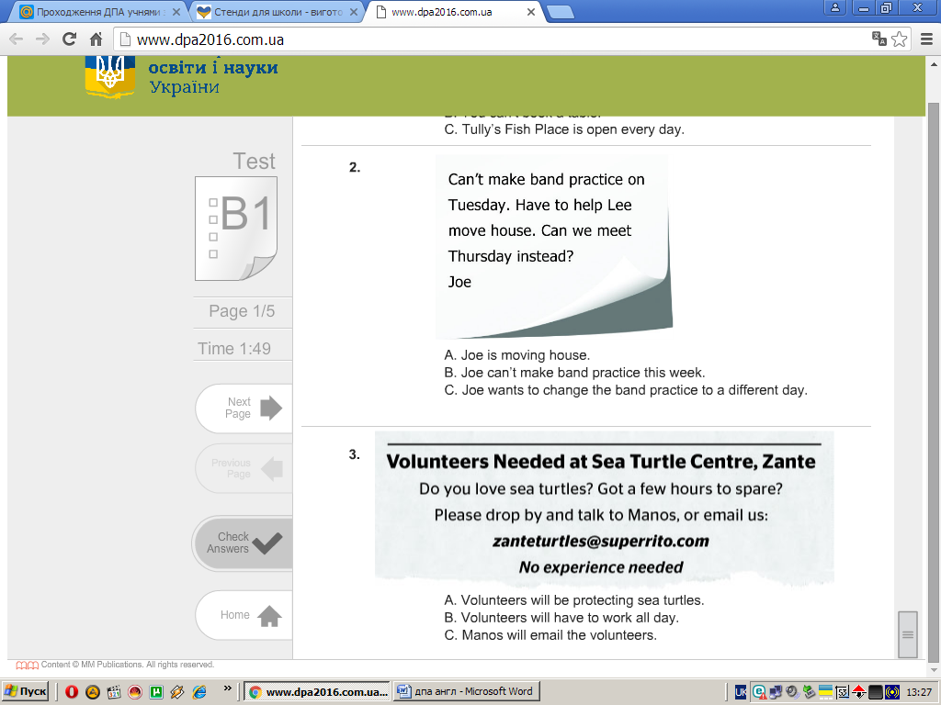

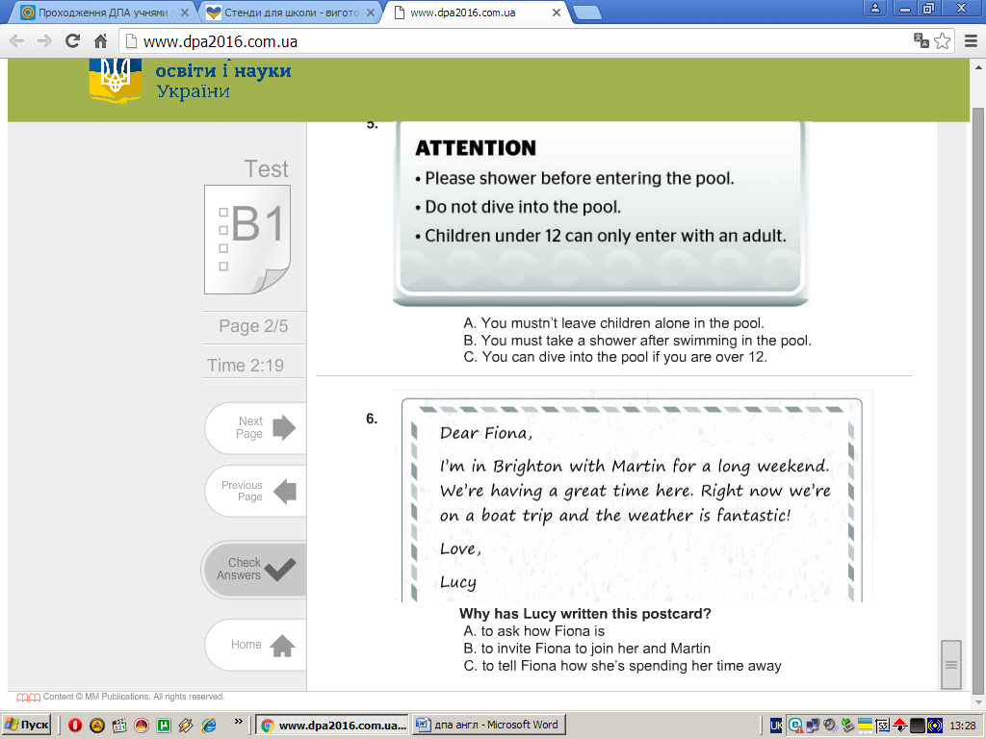

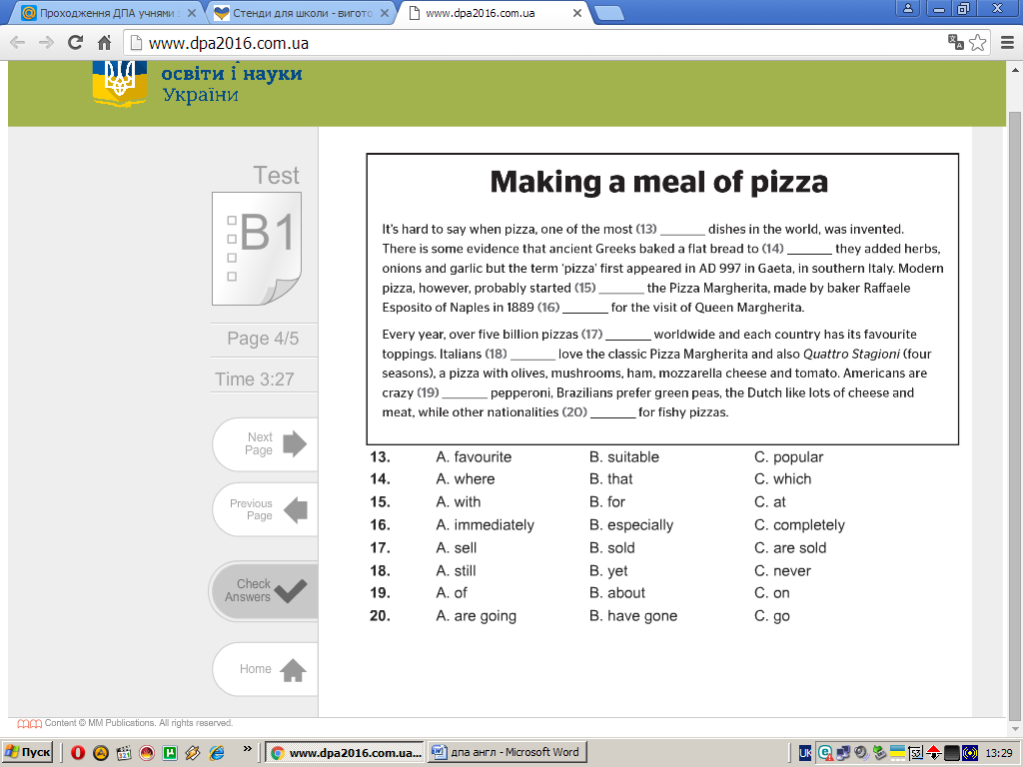**Task 2**. Choose the correct variant to fill in the gaps:

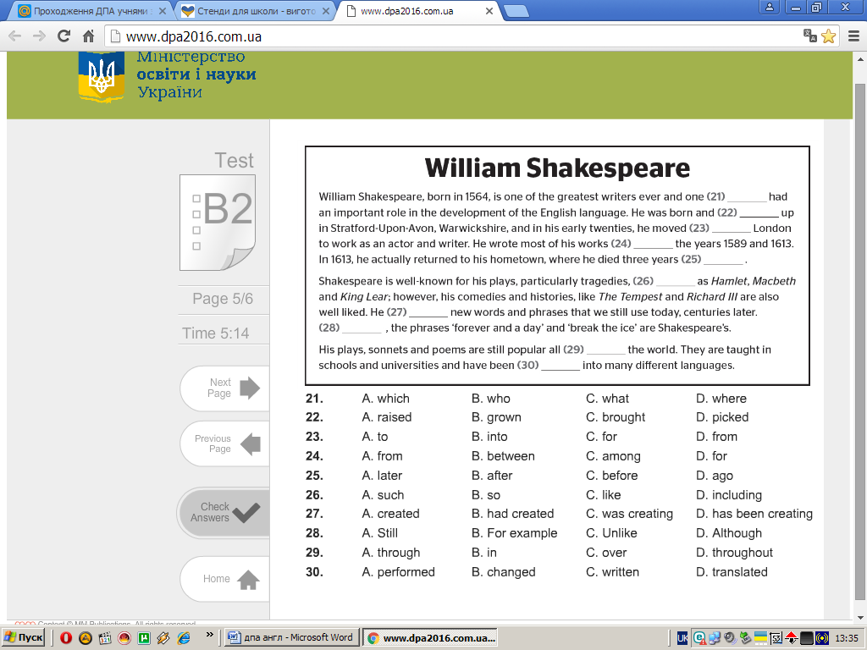

**Task 3.** You are now on holiday traveling around Europe. Write a postcard to an English-speaking friend telling him/her:

— what places you have already visited;

— what sights impressed you most;

— what you are doing now.

17

18

19

20

21

22

23

24

7

8

9

10

11

12

13

14

15

16